**Exercise 1: Display a list of names**

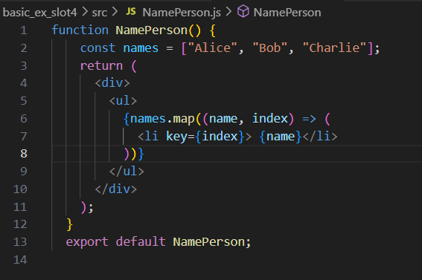



**Exercise 2: Display a person's details**

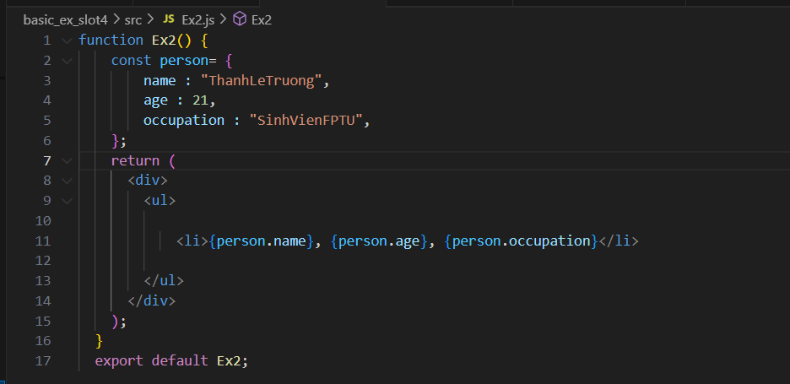



**Exercise 3:** Display a list of people (PeopleList.js)

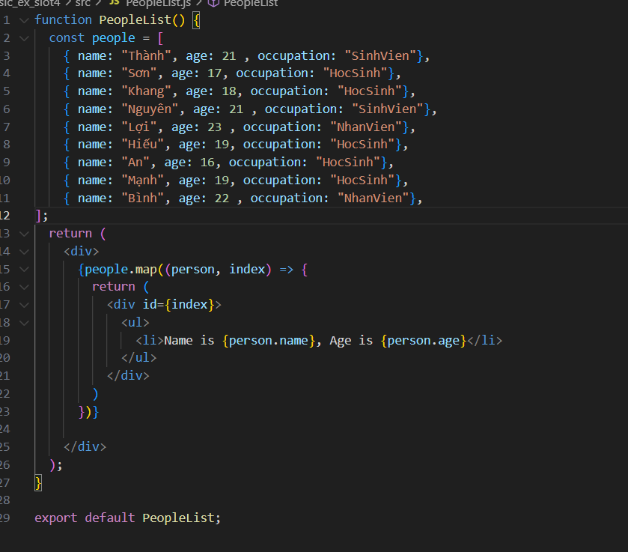

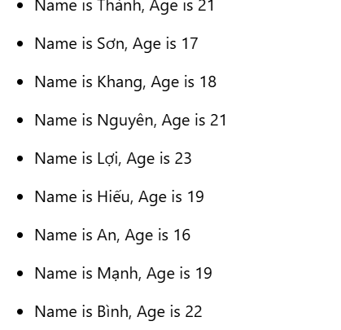

**Exercise 4:** Display a table of people

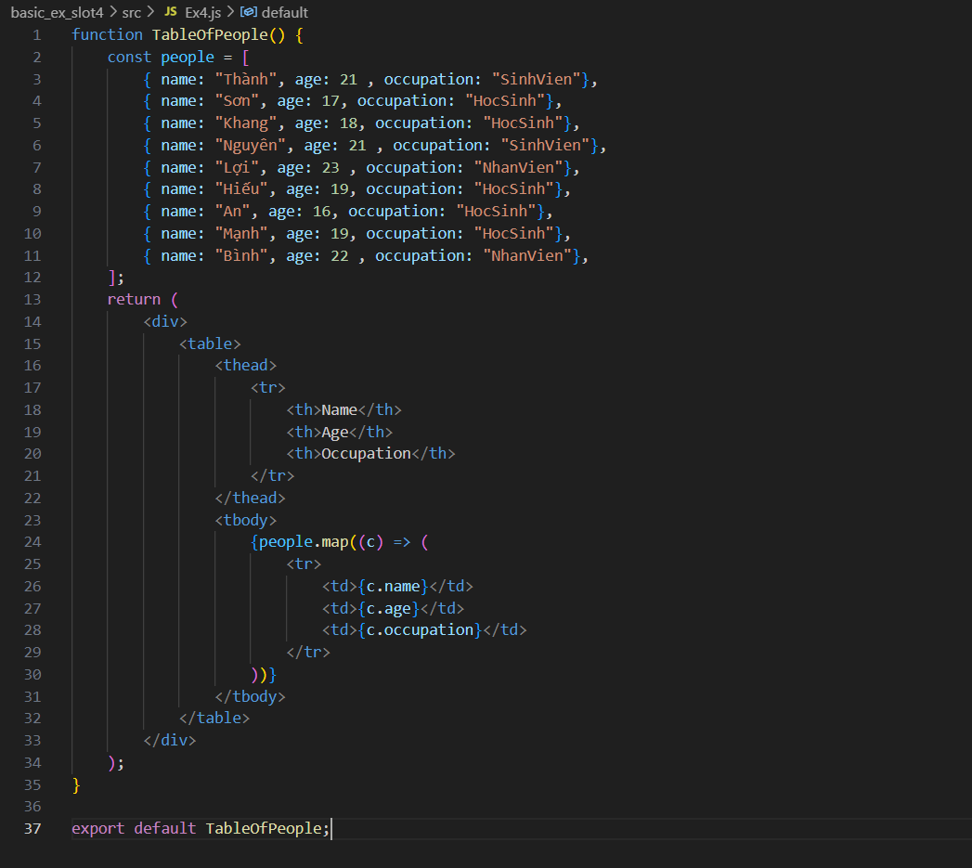

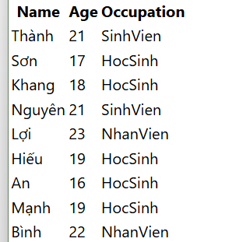

**Exercise 5:** Find the first teenager (FirstTeenager.js)

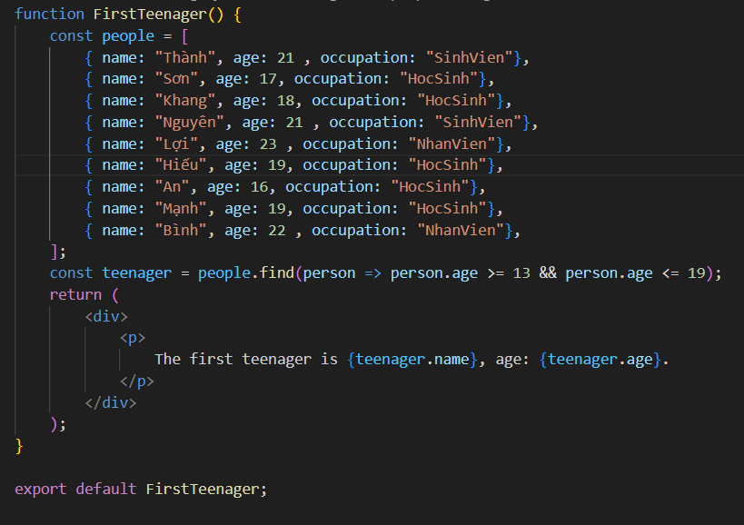

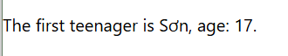

**Exercise 6:** Check if all are teenagers (AreAllTeenagers.js)

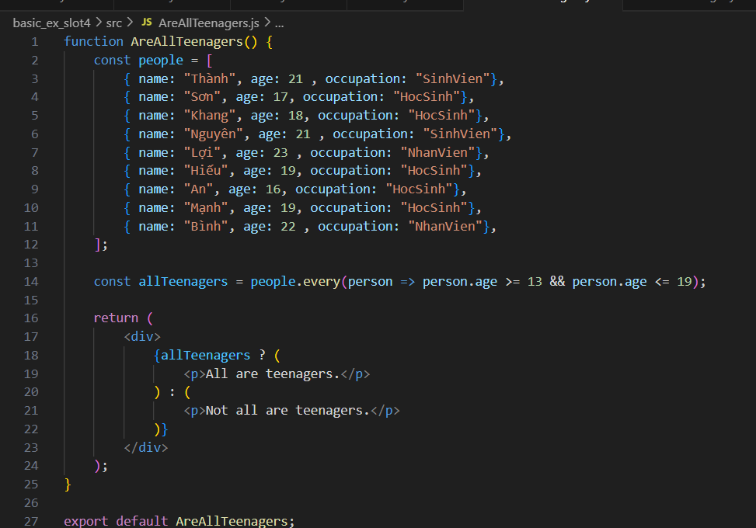



**Exercise 7:** Sort by Occupation and Then by Age

Write a function to sort the people array first by occupation alphabetically and then by age in ascending order within each occupation group.

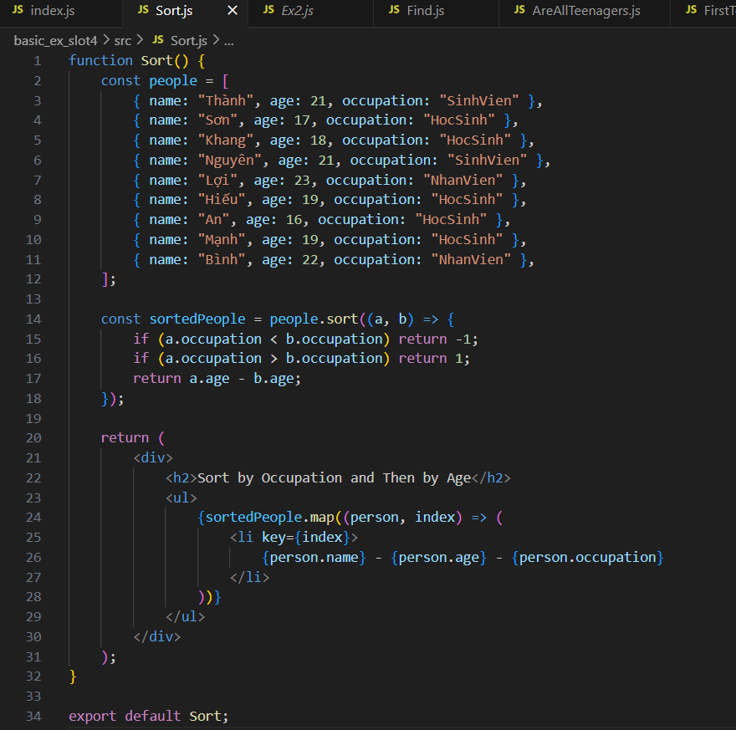

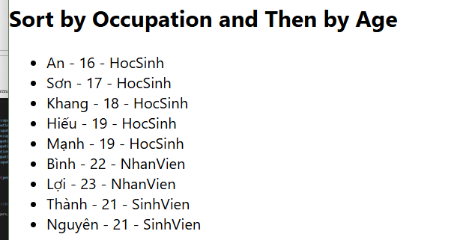

**Exercise 9:** Find the Oldest and Youngest Person

Create a function to find and display the oldest and youngest person in the array.

